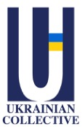

Ukrainian Collective
Progress Report

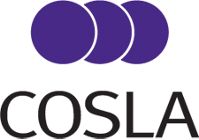


August 2024

Table of Contents
1. Introduction 3
2. Background and purpose 3
3. Executive Summary 3
4. Conception and Start-up 4
5. Key activities and achievements overview 5
6. Strengths, Challenges and Issues 12
7. Future Priorities 13
8. Recommendations 14
9. Conclusion 14
10. Authorship and acknowledgments 15
APPENDIX A 16

"The most valuable aspect of the project is the ability to build networks and provide an opportunity to convey the problems faced by displaced Ukrainians to the government. It was also impressive that, although not all recommendations for improving the situation of displaced Ukrainians were implemented, the Ukrainian Collective's input was still taken into consideration."

Collective member

1. Introduction
This report provides a comprehensive and detailed overview of the inception, rationale and activities of the Ukrainian Collective over the past 20 months. It outlines the successes and challenges faced in its endeavours to inform and influence the integration of displaced Ukrainians across Scotland and presents future plans and recommendations for consideration.

2. Background and purpose
The Ukrainian Collective was established in January 2023 based on an innovative concept generated by Scottish Refugee Council who have supported and facilitated its development throughout. The Collective represents a concerted effort to empower and support displaced Ukrainians across Scotland. Comprising individuals with lived experience with diverse backgrounds and expertise, the Collective focuses on addressing critical integration challenges in areas such as housing, employment, and language & culture. This report aims to outline the Collective's key activities, achievements, challenges, and future priorities in advocating for policy changes that foster integration and cultural understanding within Scottish society.

Driven by a commitment to collaboration, the Ukrainian Collective engages extensively with governmental agencies, third-sector organisations, and community groups. Through structured subject groups and participation in forums like the Scottish Government’s Stakeholder Reference Group, the Collective presents targeted recommendations aimed at overcoming barriers faced by Ukrainians in Scotland.

The Collective pursues its mission to amplify Ukrainian voices and secure clearer pathways to integration with the main priorities focused on bolstering advocacy efforts, expanding partnerships, and influencing policy changes at local and national levels.

This report provides an overview of the Ukrainian Collective's journey, highlighting achievements, challenges, and strategic objectives as it continues to advocate for the rights and welfare of displaced Ukrainians in Scotland.

3. Executive Summary
The Ukrainian Collective is a group of individuals with lived experiences of displacement, residing across Scotland from Inverness to Dumfries. Organised into subject groups covering Housing, Employment, and Language & Culture, they have developed extensive networks and leverage diverse expertise, including Law, Economics, Health, Art, and Culture, to address the multifaceted needs of displaced Ukrainians. The Collective emphasises collaboration and partnership with governmental agencies, third-sector organisations, and community groups to advocate for policies that promote integration, cultural understanding, and social cohesion.

Facilitated by the Scottish Refugee Council, the Ukrainian Collective was established in January 2023. Members were organised into relevant subject groups, initiating discussions to address key challenges faced by the Ukrainian community in Scotland. Since its inception, the Collective has accomplished the following key activities and achievements:
- In the framework of the Stakeholder Reference Group meetings, a formal forum established by Scottish Government Ministers to engage with the Ukrainian community in Scotland, the representatives of the Collective presented a list of recommendations to address the challenges and barriers of the Ukrainian community in Housing, Employment, and Language & Culture, and highlighted the issues that visa uncertainty causes for successful integration;
- Supported the Empowering Transition Research conducted by the Scottish Government's research team in September-October 2023 by facilitating community involvement, actively participating in research workshops, and contributing to subsequent discussions on the findings;
- Participated in various relevant forums, including the Scottish Parliament Cross-party Group, Ukrainian Community Integration Networks, and all-party parliamentary groups, to promote recommendations and raise issues concerning the Ukrainian Community;
- Advocated for the improvement of development of policies by submitting relevant proposals and running community consultations and engagement events to contribute to the New Scots Refugee Integration Strategy;
- Engaged with relevant stakeholders from COSLA, the Scottish Government, and third-sector organisations to raise the issues of the Ukrainian community, propose possible solutions, and discuss collaboration prospects.

Despite challenges, including prolonged delays in feedback on their recommendations, the Collective's commitment and collaboration with various stakeholders have led to substantial achievements, promoting integration and cultural understanding within Scottish society.

Future priorities include strengthening advocacy and policy development efforts, maintaining an active presence in policy discussions, and expanding networks and partnerships to enhance support for displaced Ukrainians. To achieve our future priorities and aspirations, we recommend that the Collective is restructured to align with the evolving context in which we operate in order can enhance our collective impact and effectiveness in addressing key community issues.

4. Conception and Start-up
By November 2022, over 17,000 displaced Ukrainians had arrived in Scotland, confronting numerous challenges related to integration, such as securing housing, finding employment, and overcoming language barriers. Despite these significant hurdles, there were limited resources and support channels available to facilitate their successful integration into Scottish society. Recognising this critical gap, the Ukrainian Collective was established to harness the diverse expertise of displaced Ukrainians and foster collaboration with governmental agencies, third-sector organisations, and community groups.

The formation and operation of the Ukrainian Collective were facilitated by Scottish Refugee Council in line with its Strategic Priorities ‘Nothing about refugees without refugees’ which seeks to improve the integration of refugees in Scotland by enabling refugee voices to be heard. The model of the Ukrainian Collective was designed to empower the voices of the Ukrainian community within the realm of policymaking. It aims to leverage the qualifications, expertise, and lived experiences of individuals displaced from Ukraine to ensure that the unique perspectives and needs of the Ukrainian community are effectively communicated to policymakers through the Stakeholder Reference Group meetings as well as other opportunities, thereby fostering more informed and responsive decision-making.

With the formal Terms of Reference established in November 2022, the recruitment of members began in late 2022.The announcement circulated through social media channels, community groups, and third-sector organisations across Scotland and the initiative was well received within the Ukrainian community, with over 40 individuals expressing a desire to participate. After a series of introductory meetings to explain the purpose of the Collective and the responsibilities of its members, 38 individuals submitted application forms to join the Collective.

The establishment of the group was finalised in January 2023 when members were allocated into subject groups encompassing Housing, Employment, and Language (later evolving into Language & Culture), with designated Subject group Chairpersons, Deputies, and Secretaries in each group. Following this, the Chairpersons initiated online discussions within their respective groups to identify key challenges and barriers faced by the Ukrainian community in Scotland and propose a list of relevant interventions to address them.

5. Key activities and achievements overview
“This group gives a strong voice to those who have arrived from Ukraine through displacement and will continue to help inform the response and development of policy.”
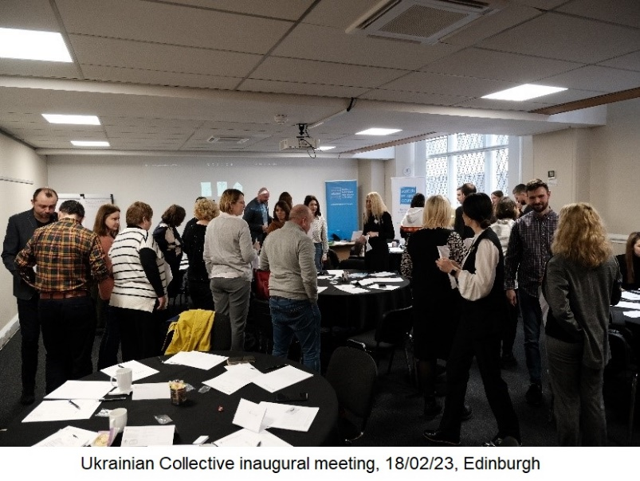
A Warm Scots Future Policy Position Paper, Scottish Government, September 2023

5.1 Inaugural Meeting

Initially, a list of recommendations addressing issues in Housing, Employment, and Language & Culture was presented at the inaugural meeting organised by Scottish Refugee Council on February 18, 2023, in Edinburgh. This presentation provided a valuable opportunity to share the proposals with members of other subject groups, allowing them to offer comments, feedback and proposals. Additionally, it facilitated engagement with representatives from third-sector organisations, enabling a broader discussion on the proposed interventions.

5.2 Stakeholder Reference Group

The recognition of the advantages of incorporating the lived experiences of displaced Ukrainians into policy responses by the Scottish Government, resulted in a ministerial-led Stakeholder Reference Group (SRG) being established to amplify the voices of Ukrainians who have resettled in Scotland. As representatives within this group, the Ukrainian Collective presented its recommendations to Scottish Government officials, third-sector representatives, and volunteer communities through a series of thematic online meetings. The Collective played a crucial role in shaping the Stakeholder Reference Group's agenda, ensuring that discussions addressed the key concerns of the Ukrainian community and enhancing the relevance of policy recommendations. As a result, the initial three meetings were tailored to the Collective's focus areas: housing, employment, and language and culture. A subsequent meeting concentrated on visa uncertainty, another critical issue affecting the integration of displaced Ukrainians.

As of August 2024, six SRG meetings have been held. A brief overview of the SRG meetings held so far can be found in Table 5.1.

Table 5.1 SRG meetings overview
# | Date | Topic | Activity description | Result
1 | 07/03/23 | Housing | UC recommendations on Housing presented | SG shared a feedback on the UC recommendations on 28/09/24
2 | 08/06/23 | Employment | UC recommendations on Employment presented | No feedback on recommendations received
3 | 04/10/23 | Language & Culture | UC recommendations on Language & Culture presented | No feedback on recommendations received
4 | 21/11/23 | Visa uncertainty | UC presented challenges caused by visa uncertainty for people displaced from Ukraine | UC presentation was used to support evidence for “Clarity on visas for displaced Ukrainian people: letter to UK Government”
5 | 12/03/24 | Reflections | UC presented reflections on collaboration within SRG | NA
6 | 13/08/24 | New Scots Delivery Plan | New Scots Delivery Plan presentation and discussion | NA

The first SRG meeting was held on March 7, 2023, and focused on housing issues. Representatives of the Housing Subject Group of the Ukrainian Collective presented challenges they had identified and relevant solutions to facilitate access to housing for displaced people from Ukraine. A total of 26 interventions were presented, including the introduction of practical guides on housing in Scotland, launching drop-in sessions for housing advice, promoting online support platforms, involving local authorities in housing schemes and engaging the community in sharing experiences.

On September 28, 2023, the representatives of the Ukrainian Collective received feedback on the proposed solutions from the Scottish Government, along with the status of the implementation of relevant interventions. Subsequently, relevant comments on the feedback were provided by the representatives of the Ukrainian Collective during the following week.

Key issues in the Employment sphere, along with recommendations to address them, were presented on June 8, 2023. Recommendations emphasized the need for several interventions to support the employment of displaced people from Ukraine, such as the development of effective job search tools, facilitation of qualifications recognition, and motivation of local employers. Employment subject groups also contributed to the development of the “Employment and Career Support for Ukrainians in Scotland” leaflet, published on February 9, 2024, to support the employment endeavours of displaced people from Ukraine within Scotland.

A Language & Culture presentation was delivered on October 4, 2023, and included a set of recommendations for solving problems with language learning tailored to the needs and levels of different groups of displaced Ukrainians. Recommendations included increasing the intensity to 2-3-5 classes per week, combining online training with live training within one course, implementing an individual approach to determine the most effective language learning based on the student’s abilities, and creating a list of English learning programmes and courses available throughout Scotland. Additionally, the importance of a holistic approach to cultural integration was emphasized, underscoring the need for a diverse range of cultural activities to promote integration, such as library visits, history, art, music, discovering national traditions, and cooking.

On November 21, 2023, representatives from the Ukrainian Collective outlined the challenges and barriers faced by people displaced from Ukraine due to visa uncertainty at the dedicated SRG meeting. These findings were subsequently communicated in the relevant “Clarity on visas for displaced Ukrainian people: letter to UK Government”. The letter aimed to contribute to finding suitable visa solutions and presumptively influenced the UK government's decision on extending visas for displaced Ukrainians announced in February 2024.

On March 12, 2024, a Stakeholder Reference Group meeting was held to reflect on the progress made since the first meeting in March 2023. The representatives of the Ukrainian Collective presented their reflections on the results achieved, current issues, and future collaboration.

Finally, as members of the Stakeholder Reference Group, the members of the Collective were provided with an opportunity to comment on relevant policies. In response to the Scottish Government's request on June 29, 2023, the representatives of the Ukrainian Collective submitted a paper with proposed potential solutions to the Warm Scots Welcome – Future Policy Strategies. These proposals included implementing "Minimum Standard" service standards nationwide, easing the shift to the private rental market, refurbishing void properties, adopting an individual-based approach, and advocating for clear post-three-year visa policies from the UK Government to promote integration, enhance stability, and improve the overall well-being of displaced Ukrainians residing in Scotland.

5.3 Scottish Refugee Council – Ukrainian Community Integration Networks
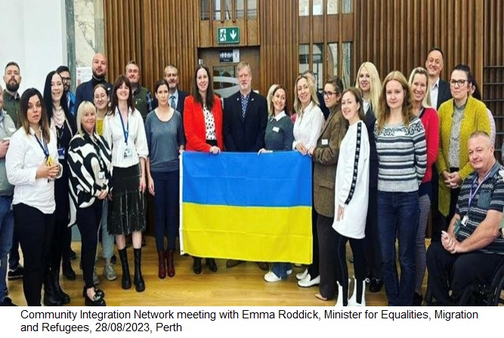
Between April-September 2023, representatives of the Ukrainian Collective attended several Ukrainian Community Integration Networks meetings across various areas of Scotland, including Dundee, Glasgow, Highland, and Perth & Kinross organised by Scottish Refugee Council to facilitate collaboration among Local Authorities, third-sector organisations, refugee-supporting community groups, and representatives from Ukrainian communities. This opportunity allowed the group to enhance advocacy for the proposed recommendations among third-sector representatives and volunteer organisations, and to raise awareness about the available support for people displaced from Ukraine. On September 28, 2023, at the Integration Network meeting in Perth, with Minister Emma Roddick MSP in attendance, a presentation by the Ukrainian Collective highlighted the actual barriers and issues faced by the Ukrainian community. This event provided a platform to discuss the challenges encountered by those displaced from Ukraine living in Scotland and to propose relevant solutions.

5.4 Empowering Transition Scottish Government Research

In September-October 2023, the Ukrainian Collective supported the Empowering Transitions research project conducted by a public service design team in Scottish Government to identify barriers and motivations affecting displaced people's decisions to leave welcome accommodation. The participants for the Glasgow workshop were recruited via the Ukrainian Collective’s network – the Collective also helped Scottish Government to recruit for a similar workshop in Inverness. Additionally, representatives from the Collective contributed to making sense of the research to ensure the practicality and validity of research assumptions and provided feedback on the findings in subsequent meetings attended by representatives from Local Authorities, COSLA, Scottish Refugee Council, and Scottish Government.

5.5 Cross-party group


The Ukrainian Collective have been actively engaged in the Scottish Parliament Cross-party Group on Ukraine where the Chairwoman of the Housing Subject group served
as the Secretary, while several members of the Collective have participated in the group meetings since its establishment. The first meeting, held in December 2023
saw an active contribution from
Sabir Zazai, who highlighted the issues and challenges faced by the Ukrainian community in Scotland and the work of the Ukrainian Collective in tackling them. Additionally, a representative of the Collective was invited to join the Resettlement Working Group.

5.6 New Scots Refugee Integration Strategy


As part of the Scottish Refugee Council initiative to involve refugee voices in the formation of priority actions for the revised New Scots Refugee Integration Strategy, representatives of the Ukrainian Collective actively participated in discussions regarding the Strategy at the engagement events held in various areas of Scotland, including Edinburgh, Glasgow, Dundee, and Aberdeen in November 2023. In addition, January 2024, with the organisational support of Scottish Refugee Council, the Ukrainian Collective hosted a community consultation event aimed at contributing to the vision and outcomes outlined in the New Scots Refugee Integration Strategy.

The comments below highlight various interventions and suggestions from local organisations, Ukrainian associations, community hubs, faith-based communities, and public bodies in supporting the integration of Ukrainians in Scotland. These efforts can be linked with the outcomes of the New Scots delivery plan as follows:

# | Outcome | What’s being done well | Suggested improvement
1 | New Scots live in safe, welcoming, inclusive communities, where everyone's dignity is respected and everyone is able to build diverse relationships and healthy intercultural bonds. | Local Community Hubs and Faith-Based Communities create safe spaces where Ukrainians and other displaced persons can integrate comfortably into Scottish society. | Enhancing communication and engagement with Ukrainians who have first-hand experience and language proficiency can further promote inclusivity. An open dialogue between local authorities and the community will help address specific needs and improve integration
2 | New Scots are able to access well-coordinated services, which recognise and meet their rights and needs | Various services in big cities like Dundee and Kirkcaldy, along with employment and learning activities, support the coordination of services to meet the rights and needs of New Scots. Aberdeen City Council’s collaboration with landlords and the sufficient number of ESOL providers in Aberdeen | Improve accessibility and engagement with services for Ukrainians who may have language barriers or are unfamiliar with the service systems. Enhance housing services and support mechanisms tailored for Ukrainians who are not proficient in English.
3 | New Scots understand their rights, responsibilities and entitlements in Scotland and able to exercise these to pursue full and independent lives. New Scots can pursue their ambitions through education, employment, culture and leisure activities in diverse communities | Universities, colleges, and Ukrainian Sunday schools provide platforms for pursuing education and cultural learning.  Organisations like CEIS and People Plus assist with employment support and the creation of businesses, facilitating economic integration. | Streamline the process for recognising degrees, qualifications, and overseas experience, facilitating smoother integration into the workforce. Develop and expand programs that support professional development tailored to the needs of Ukrainians in fields such as medicine, law, and business.
4 | Communities in Scotland understand integration inter-culturally and respect the diversity and strengths that New Scots bring | Cultural Events and Ukrainian Associations contribute significantly to fostering cultural exchange and community cohesion. | More active engagement of Ukrainians in local decision-making processes, fostering an open dialogue with local authorities can enhance intercultural understanding and respect within the community
5 | Policy, strategic planning, and legislation, that have an impact on New Scots, are shaped through their participation and informed by their rights, needs and aspirations | Organisations such as Scottish Refugee Council, Settled UK, and Just Right Scotland advocate for the rights and needs of displaced persons, influencing policy at the national level | There is some involvement in policy-shaping processes; however, there is a need for greater representation and participation from Ukrainian communities in decision-making forums
6 | The principles of the New Scots Refugee Integration Strategy guide all future responses to crises that bring forced migrants to Scotland and seek to ensure all such migrants will be treated equitably | Organisations and councils in Aberdeen provide crucial support, including psychological assistance, educational programs, and housing support during crises.  The Law Society of Scotland and the Faculty of Advocates offer legal support, ensuring equitable treatment and rights protection. | Advocate for clearer pathways to visa extensions and settled status, providing stability and security for Ukrainians facing uncertain futures

5.7 Engagement with Other Stakeholders

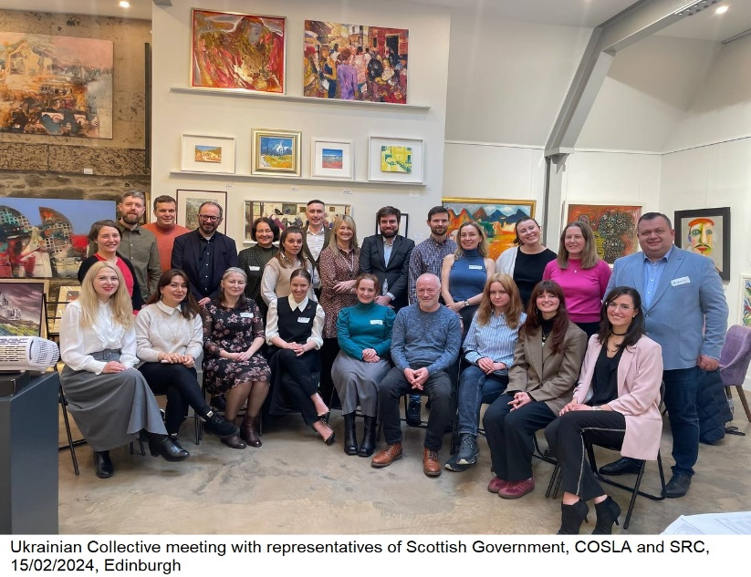
1) On May 4, 2023, Scottish Refugee Council arranged and facilitated meeting with representatives of COSLA to discuss the recommendations of the Subject Groups. This meeting served to explore potential collaboration opportunities and discuss the capacities of Local Authorities and COSLA to implement the interventions proposed by the Ukrainian Collective.

2) In April-May 2023, representatives of the Collective met with Scottish Refugee Council subject experts to synergise efforts in supporting communities. This included meetings with the Refugee Festival Manager, Employment Officer, and Arts and Cultural Development Officer to discuss planned activities and projects and the potential to build on them to support Ukrainian communities. These meetings helped raise awareness about the resources and assistance that Scottish Refugee Council offers to displaced people in Scotland, and facilitated the development of more informed recommendations.

5.8 Other Engagement Opportunities Taken

1) Collective representatives were involved in the All-Party Parliamentary Group on Social Integration Refugee Accommodation Round-table to discuss housing related matters of the Ukrainian community within the Scottish context with other third-sector and community group representatives.

2) The Ukrainian Collective facilitated the engagement of individuals with lived experience in three workshops held in Edinburgh in November-December 2023, as part of the British Red Cross and Safe to Grow research programme on Ukraine Accommodation. On July 16th a report was published, acknowledging the Collective’s involvement, which outlined recommendations for policymakers to enhance the UK's response while building on existing successes to strengthen overall refugee protection.

3) On February 15, 2024, with the support of Scottish Refugee Council an in-person event with representatives from the Ukrainian Collective, Scottish Government and COSLA was organised in Edinburgh. Attendees included the Head of Unit and Policy Manager on Asylum and Refugee Integration, as well as the Ministerial Briefing and Communications team of the Scottish Government. The representatives of the Ukrainian Collective delivered a presentation on the recommendations, achievements, and engagements of the group over the past year since its establishment. This was followed by a discussion on the strengths and weaknesses of the Collective and its desired level of involvement in influencing decisions and policies affecting the Ukrainian community across Scotland.

6. Strengths, Challenges and Issues
As identified in the meeting on February 15, 2024, with the members of the Scottish Government and COSLA, the following key strengths of the Collective were highlighted:
- The Collective benefits from the diverse experiences of its members, who come from various geographical areas and participation schemes, and from its significant representation of women. This diversity enriches its perspectives and advocacy efforts.
- The Collective has an opportunity to influence policy by presenting recommendations to the Scottish Government (SG) and acting as a bridge between the Ukrainian community and SG, clearly defining problems and sharing successful experiences.
- The Collective fosters economic connections, cultural learning opportunities, and highlights key policy areas based on lived experiences, creating solutions through consultations and sharing success stories.

However, the participants also identified some key weaknesses hampering the Collective’s progress, these included:
- The ‘loose’ organisational structure and governance, for example, the Collective lacks Key Performance Indicators (KPIs), statistical data and regular meetings which leads to operational inefficiencies and insufficient support from the start.
- It relies heavily on voluntary participation and lacks local expert input in practical areas.
- External challenges include visa issues governed by the UK government, complicating planning and stability for Ukrainians.

We recognise that since its establishment, the Ukrainian Collective has faced a series of significant challenges, both in our desired level of involvement and in managing our expectations of timescales and process. One of the primary issues has been maintaining member engagement on the proposals and initiatives. The complexity of the challenges and barriers facing the Ukrainian community in Scotland, coupled with the difficulty of finding suitable solutions that consider the interests of both displaced Ukrainians and other communities, was anticipated from the outset. However, prolonged delays in receiving feedback and comments on these recommendations have notably impacted the motivation of the Collective's members.

For instance, feedback on the housing recommendations took more than six months to arrive. Meanwhile, proposals concerning employment, presented in June, and those on language and culture, presented in October, have yet to receive any feedback. These long lags in response time have created frustration and disillusionment among members, undermining their enthusiasm and willingness to remain actively involved. The absence of timely feedback not only hampers the momentum of ongoing projects but also weakens the Collective's ability to advocate effectively and implement necessary changes. Moving forward, addressing these delays and improving communication channels with stakeholders will be crucial to sustaining member engagement and ensuring the successful realisation of the Collective's goals.

In addition to the challenges of maintaining engagement among its members, the Ukrainian Collective operates within a highly volatile and uncertain context, significantly impacting the community of displaced Ukrainians in Scotland. One of the most pressing issues is the lack of clarity regarding the future status of visas for Ukrainians. The lack of a stable legal status also impacts displaced Ukrainians' access to essential services, employment opportunities, and housing, further complicating the integration process. This uncertainty makes it difficult for the Collective to plan long-term initiatives and advocate effectively for integration measures. Addressing these issues requires a concerted effort to advocate for clearer, more stable immigration policies that provide displaced Ukrainians with the security they need to rebuild their lives in Scotland.

The Ukrainian Collective highlighted the need for clarity on whether displaced individuals from Ukraine will be able to remain in the UK after their extended visa period expires, and what potential pathways to citizenship might be available.

7. Future Priorities
In the next period, the Ukrainian Collective will prioritise strengthening its advocacy and policy development efforts to ensure that the voices of displaced Ukrainians are heard and their needs addressed at both local and national levels. The following recommendations, from the meeting on February 15, 2024, regarding our key areas for our desired level of involvement included:
- The Collective aims to influence Local Authorities (LAs) and overall policy, with experienced advisors helping solve issues and advocate effectively.
- It seeks to be involved in thematic working groups and provide feedback loops with SG, Local Authorities and COSLA, ensuring collaborative policymaking.
- The Collective wants to expand its impact to support other displaced people, recognise changing needs, and adapt policies accordingly.

Continued advocacy will involve maintaining an active presence in policy discussions with the Scottish Government and other relevant stakeholders. Given the critical importance of visa issues for the Ukrainian community, it would be highly beneficial to expand collaboration to a UK-wide level to advocate for clear guidelines on the long-term prospects for displaced Ukrainians.

The Collective aims to influence policy changes that facilitate better integration and support for Ukrainians in Scotland, addressing critical issues such as housing, employment, and social services. Monitoring the implementation of existing policies and providing regular feedback to government agencies will be essential in ensuring these policies effectively meet the community's needs. Additionally, the Collective will seek opportunities to play an active part in the implementation of the New Scots Delivery Plan, engage in national forums and discussions on refugee and migrant integration, contribute to broader policy development and promoting best practices that can be adopted across the UK.

Expanding networks and partnerships is another key priority for the Ukrainian Collective, aiming to enhance the support system for displaced Ukrainians through strengthened collaborations. Building robust partnerships with third-sector organisations will be crucial in coordinating efforts and leveraging resources for comprehensive support services. The Collective will work to foster stronger connections within the Ukrainian community and between different refugee and migrant groups, creating a supportive network that enhances community resilience and solidarity. By building these extensive networks, the Collective can ensure a more integrated and holistic approach to addressing the multifaceted needs of displaced Ukrainians, facilitating their successful integration into Scottish society.

8. Recommendations
Reflecting on our experiences and the feedback we have received we believe that a formalisation of our structure and our aspiration to formalise the Collective's role, making it more official with positions in LAs and SG, and establishing consistent procedures across LAs. As identified above, ongoing progress, processes and stakeholder engagement have evolved, making the current division into thematic areas within the Collective less relevant. Therefore, restructuring the Collective's framework to align with this evolving context in order to achieve our future priorities and aspirations can enhance our collective impact and effectiveness in addressing key community issues.
It is important, whilst we address our structural challenges, that we continue to move forward on the Collective’s collaboration with governmental agencies, third-sector organisations, and community groups as this evolve through further discussions. It is crucial to discuss and clarify the role and capacity of the Scottish Refugee Council in supporting the development of the Ukrainian Collective and addressing the challenges the group will face. This includes focusing on the following areas:
- Ensuring regular meetings with Scottish Refugee Council representatives are held to keep the group updated on any plans for further engagement so that volunteer efforts coordinated accordingly;
- Utilising Scottish Refugee Council's network resources to broaden the Collective’s opportunities, increase awareness, and strengthen advocacy efforts on matters impacting the Ukrainian community;
- Exploring the assistance Scottish Refugee Council can offer to minimize delays in receiving feedback on recommendations from the Scottish Government;
- Promoting the group through social media, interviews, or alternative platforms to boost the Collective's visibility and potential for growth;
- Discussing the nature and timeline of Scottish Refugee Council assistance in establishing an alternative organisational structure, should these changes be deemed beneficial.

9. Conclusion
Since its establishment in early 2023, the Ukrainian Collective has made substantial strides in advocating for the integration and support of displaced Ukrainians in Scotland. Through its organised efforts in Housing, Employment, and Language & Culture, the Collective has effectively harnessed the diverse expertise of its members to address the complex needs of the community. Collective’s active collaboration with governmental agencies, third-sector organisations, and community groups has led to significant achievements, such as formulation of targeted recommendations presented at various high-level forums, including the ministerial-led Stakeholder Reference Group.

Despite facing challenges, the Ukrainian Collective has demonstrated resilience and commitment to its mission. By maintaining a strong advocacy presence and building extensive networks and partnerships, the Collective continues to enhance its impact and drive meaningful change. Moving forward, the Collective remains dedicated to addressing the evolving needs of the Ukrainian community in Scotland, ensuring their voices are heard and their contributions are valued.

The Collective has also presented opportunities to participate as a peer group representing the challenges and aspirations of their communities and to contribute at a high political level and members of the Ukrainian Collective expressed their appreciation for the opportunity. One member shared: "I consider the Collective to be a fantastic project for establishing collaboration between displaced Ukrainians and the Scottish Government."
Another volunteer of the Collective highlighted: "The most valuable aspect of the project is the ability to build networks and provide an opportunity to convey the problems faced by displaced Ukrainians to the government. It was also impressive that, although not all recommendations for improving the situation of displaced Ukrainians were implemented, the Ukrainian Collective's input was still taken into consideration."
These testimonials highlight the significance of the Collective for people displaced from Ukraine, providing them a platform to directly share their experiences, recommendations, and the challenges they encounter in Scotland, ultimately facilitating the search for relevant solutions.

10. Authorship and acknowledgments
This report on the Ukrainian Collective was drafted by Andrii Nadych, a Community Development Officer for Scottish Refugee Council and reviewed with contributions from the Chairwomen of the Collective, Anna Kulish and Oleksandra Novatska to ensure a comprehensive and detailed overview of the Collective's activities, achievements, and challenges.

The "Recommendations" section was developed based on the vision and inputs of the Collective's Chairwomen, ensuring that the proposals are both practical and aligned with the group's aspirations. The dedication and commitment of Anna Kulish and Oleksandra Novatska have been crucial in shaping this report and highlighting the path forward for the integration and support of displaced Ukrainians in Scotland. I also thank Gary Christie and Jewels Lang from Scottish Refugee Council for reviewing the paper and for their invaluable input and insights.

For additional information, please contact us at CommunityTeam@scottishrefugeecouncil.org.uk

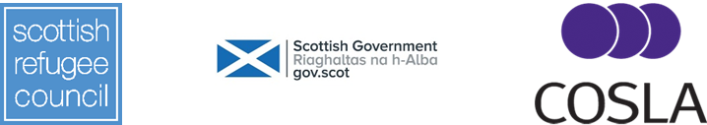

APPENDIX A

Timeline of the key activities and milestones of the Ukrainian Collective from November 2022 till March 2024.
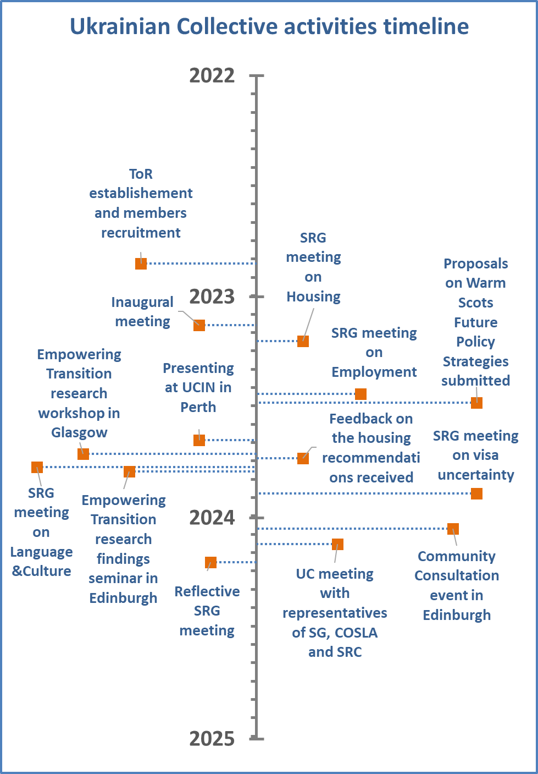

Due to various reasons, the number of members decreased to 29 by the end of 2023.

